SMAA Team App

Team App is an exciting application that you can download on your smart phone or tablet, to access the clubs communications.
You can access SMAA News, events, schedules, photos, newsletters, documents (such as rosters, application forms, etc) and sponsors.
It is also a platform where you can access your player portal, the SMAA facebook site and chat with team members.
All information is kept confidential to relevant access groups. Coaches & team manager areas require additional passwords.

- Download the 100% FREE ‘Team App’ on your smart phone or tablet. (From the App store or Google Play)
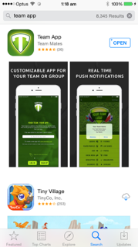
- Click ‘Sign Up’ to fill in your registration/contact details. You will need to search for SMAANC to become a member. Please note that you will be sent an email to confirm your registration.
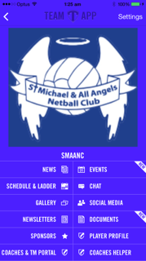
- Once you have confirmed your registration you must join the relevant “access groups”. Please make sure that you choose the groups accurately to ensure that you receive all the relevant information. Eg you will need to join the group ‘players & officials’ plus your team, but if you are a committee member , coach, team manager or umpire you will need to join these groups also.
You can change your access groups at any time by clicking on settings
- You may be able to add a shortcut to your home screen to make it easier to log straight into SMAANC. Click on settings (top RHS) and choose the “install to home screen option”, then follow the on screen prompts. This will depend on which type of device you are using.
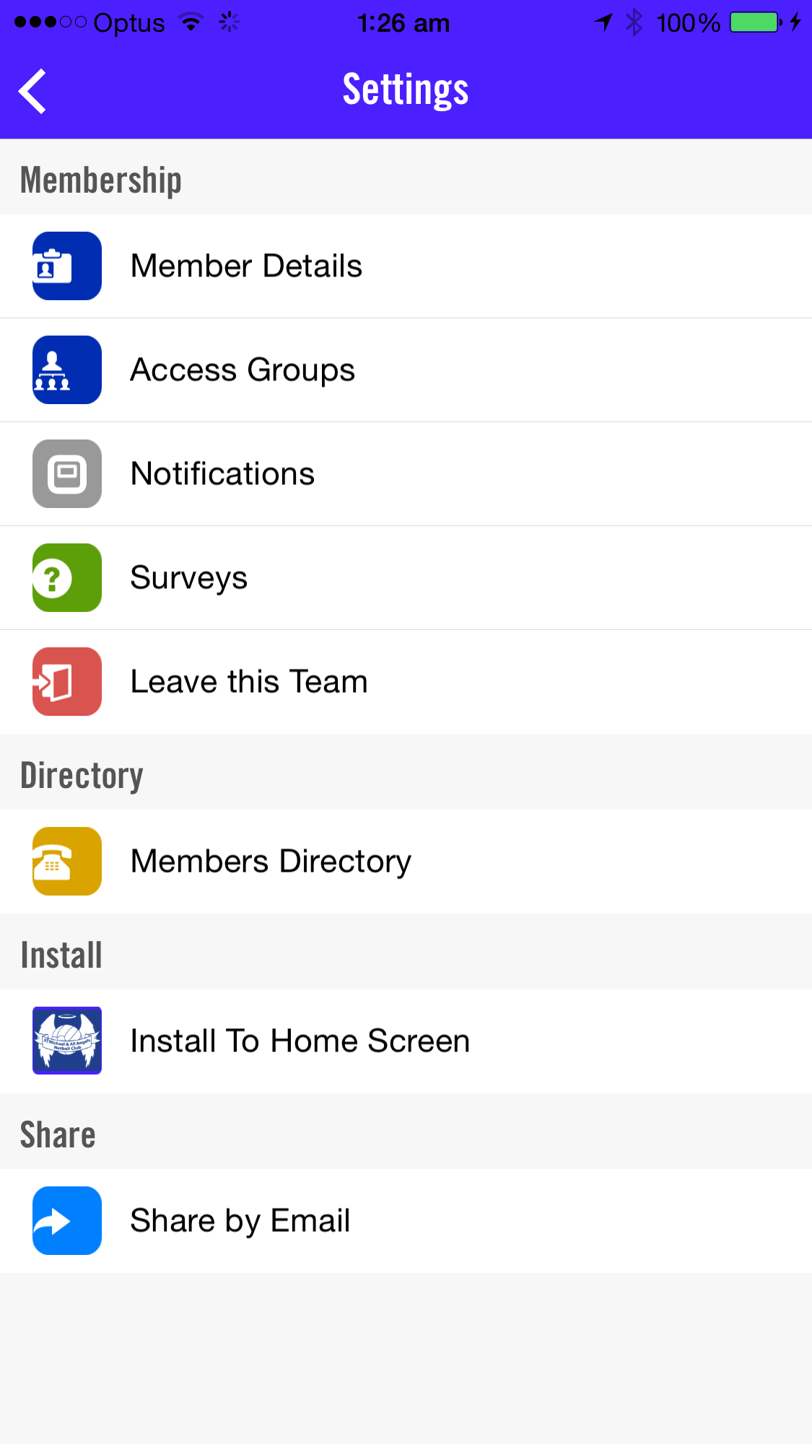

NB Please leave notifications enabled, to ensure that you receive all club correspondence immediately. If your turn off your push notifications you will receive club notifications by email. You can turn off notifications for the chat feature separately in the chat room.

