SMAA Netball Club Inc 17 994 722 184 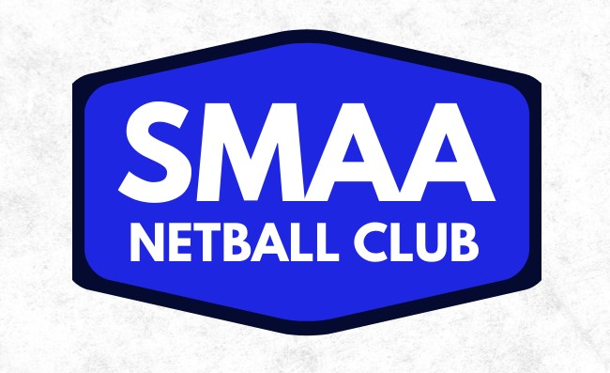

Umpire Registration Form Winter 2023

NAME: ____________________________________________________________________

ADDRESS:__________________________________________________________________

DATE OF BIRTH (if under 18yo): ____________________if Playing what Team ___________

CONTACT TELEPHONE: ______________________ (mobile)

______________________ (Parent mobile if under 18)

Payments by EFT only: BSB: ___________________________
ACCOUNT #: _____________________
BANK NAME: ____________________
Fortnightly payments or end of season _______________________________
EMAIL (must be checked regularly): ______________________________________________

EMAIL (parent if under 18): ______________________________________________

I wish to umpire: Juniors @ home courts Seniors @ association courts
(circle one or both if willing to do either)

Are you a badged umpire? Yes / No If Yes Badge held: ___ Date:________

Would you like to apply for a badge? Yes / No

Would you like to attend SAUCNA Umpire Clinics
Theory Yes / No
Practical Yes / No

Would you like to umpire Junior Carnival on 18-20th July 2023 (3 days) Yes / No

2022 Rates:-
Umpire with mentor & less than 2 calendar years experience $25/game
Umpire over 2 years (3rd year) $30/game
C Badged $35/game
A & B Badged $40/game
All finals paid by SAUCNA $30 per game

Trials will be paid an Honorarium $20 per hour or as yet by the SMAA committee

Any other Comments :
________________________________________________________________________________

Please email all forms back to
Judy Finck: judy_finck691@hotmail.com
0417 823 078

